In a binary tree, the root node is at depth 0, and children of each depth k node are at depth k+1.

Two nodes of a binary tree are *cousins* if they have the same depth, but have **different parents**.

We are given the root of a binary tree with unique values, and the values x and y of two different nodes in the tree.

Return true if and only if the nodes corresponding to the values x and y are cousins.

**Example 1:  
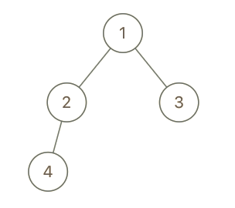**

**Input:** root = [1,2,3,4], x = 4, y = 3

**Output:** false

**Example 2:  
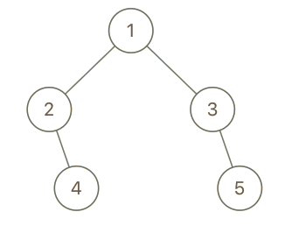**

**Input:** root = [1,2,3,null,4,null,5], x = 5, y = 4

**Output:** true

**Example 3:**

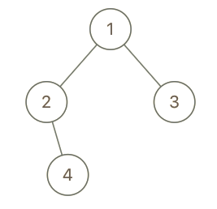

**Input:** root = [1,2,3,null,4], x = 2, y = 3

**Output:** false

**Note:**

1. The number of nodes in the tree will be between 2 and 100.
2. Each node has a unique integer value from 1 to 100.